5/22/2026
Shekhar Podutwar
22/5/2026
AWS Infrastructure Monitoring Using Prometheus and Grafana

DevOps Monitoring Solution

Contents

Document Version History…………………………………………………………………….……….1
Introduction…………………….…………………………………………………………………………….2
Objectives…………………….……………………………………………………………………………….3
Tools & Technologies Used…………………………………………………………………………….4
Architecture Overview ………………………………………………………………………………….5
Step-by-Step Implementation ………………………………….….……………………………….6

Document Version History

Version Number | Date Modified | Author | Changes
Draft | 22/5/2026 | Shekhar | Draft Version

Introduction
This project focuses on implementing a complete monitoring and visualization solution using Prometheus and Grafana on an AWS cloud environment. The monitoring setup was designed to collect real-time system and server performance metrics from Linux-based EC2 instances hosted on Amazon Web Services.
The environment was configured by securely connecting to the AWS EC2 instance using the PuTTY tool. A Node Exporter service was installed on the server to collect infrastructure-level metrics such as CPU utilization, memory usage, disk space, network traffic, and system load. These metrics were then scraped and stored by Prometheus.
Finally, Grafana was integrated with Prometheus as a data source to visualize the collected metrics through interactive and real-time dashboards. This monitoring solution helps in proactive infrastructure monitoring, performance analysis, troubleshooting, and improving system reliability

Objectives
The primary objective of this project is to design and implement a real-time infrastructure monitoring solution using Prometheus and Grafana on AWS cloud servers.
The project aims to:
- Monitor AWS EC2 server health and performance metrics in real time.
- Collect server metrics using Node Exporter.
- Configure Prometheus to scrape and store monitoring data.
- Visualize infrastructure metrics using Grafana dashboards.
- Improve system monitoring, troubleshooting, and performance analysis.
- Create centralized dashboards for better operational visibility.
- Enable proactive monitoring and alerting server resources.

Tools and Technologies
Tool / Technology | Purpose
Amazon Web Services (AWS EC2) | Hosting Linux server instances
PuTTY | Secure SSH connection to EC2 server
Linux (Ubuntu/CentOS) | Operating system for monitoring setup
Prometheus | Collecting and storing metrics
Node Exporter | Exporting server-level metrics
Grafana | Creating monitoring dashboards
HTTP / TCP Ports | Communication between services
Systemd Services | Managing Prometheus and Node Exporter services

Architecture Overview

AWS EC2 Server
│
▼
Node Exporter
(Collects System Metrics)
│
▼
Prometheus
(Scrapes & Stores Metrics)
│
▼
Grafana
(Visualizes Data in Dashboards)
│
▼
Real-Time Infrastructure Monitoring
Step-by-Step Implementation

Step1: Create 3 instances in AWS Ec2
Create the following three Linux EC2 instances in Amazon Web Services:
Server Name | Purpose
App-Server | Application hosting server
Prometheus-Server | Monitoring and metrics collection
Grafana-Server | Dashboard visualization and monitoring

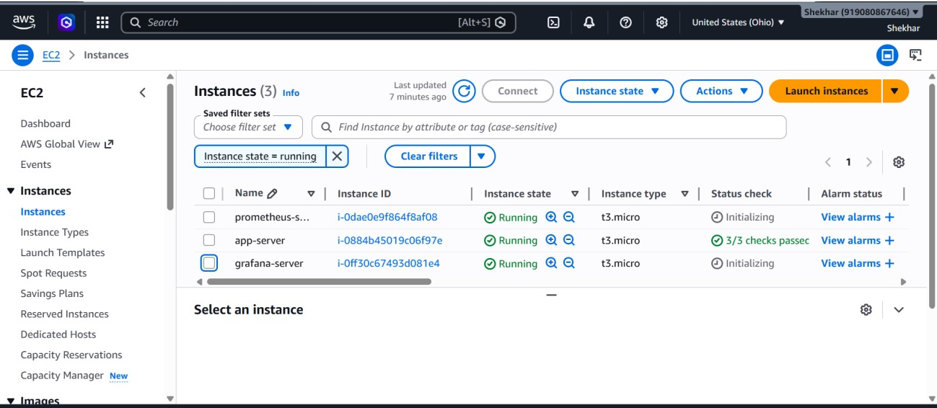

Step2: Connect putty Tool
- Connect each server through putty
- Change server name as per server’s name
- Check server name (hostname)
- Change server name (hostname servername (you want and bash)
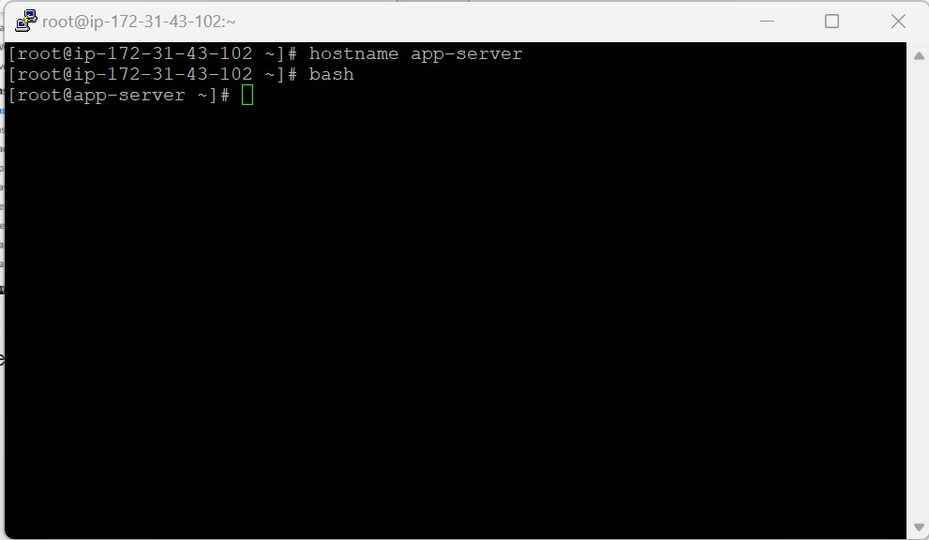

Step3: install Prometheus using putty (Prometheus –server)
- wget https://github.com/prometheus/prometheus/releases/download/v3.11.2/prometh eus-3.11.2.linux-amd64.tar.gz
- tar -xzvf prometheus-3.9.1.linux-amd64.tar.gz
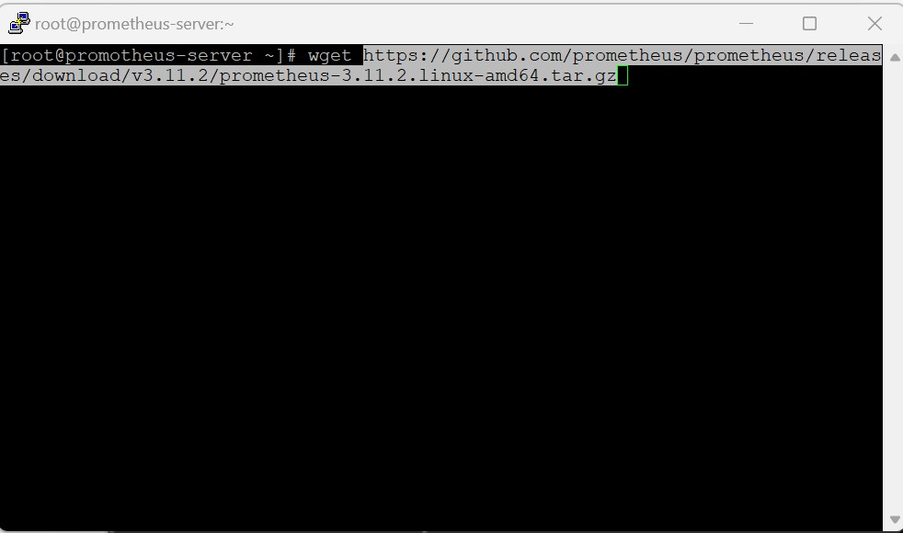
- Check file/folder name (ls)
- And unzip that file (prometheus-3.11.2.linux-amd64.tar.gz) • tar –xvzf filename
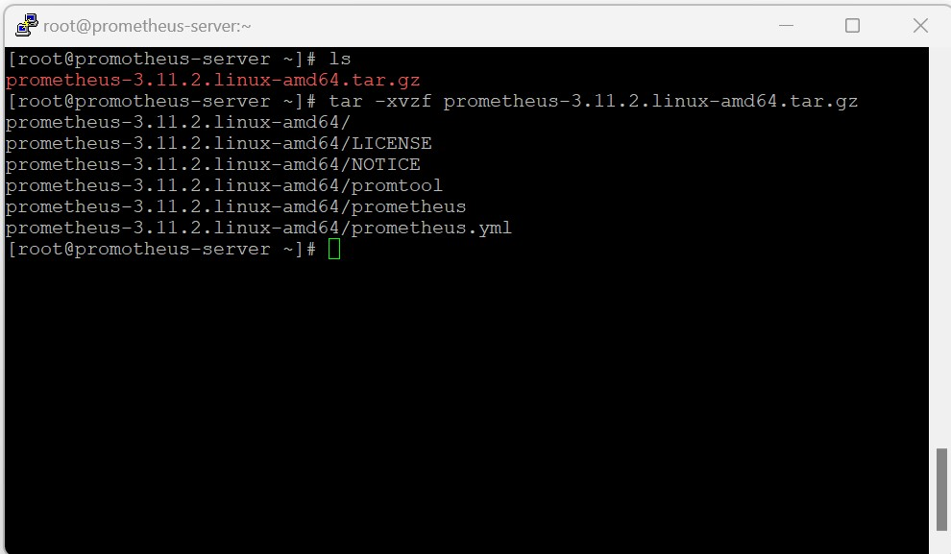
- For moving folder to opt
- mv /root/prometheus-3.11.2.linux-amd64 /opt
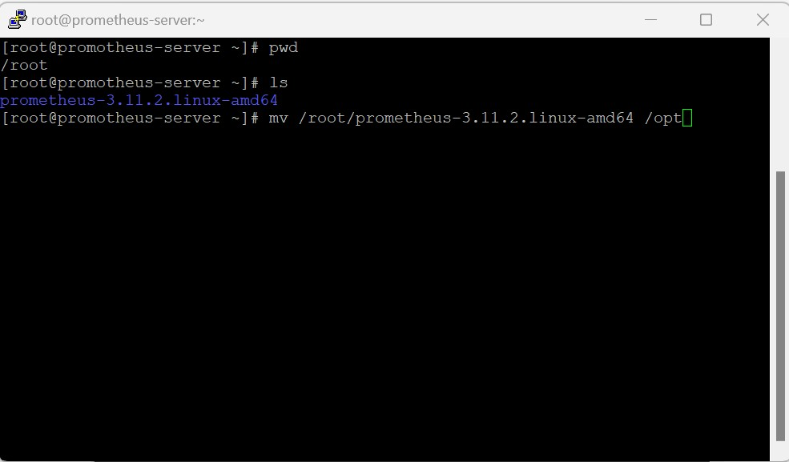

Step4: install node exporter using putty (app-server)
- wget https://github.com/prometheus/node_exporter/releases/download/v1.11.1/node_ exporter-1.11.1.linux-amd64.tar.gz
- tar -xzvf node_exporter-1.10.2.linux-amd64.tar.gz
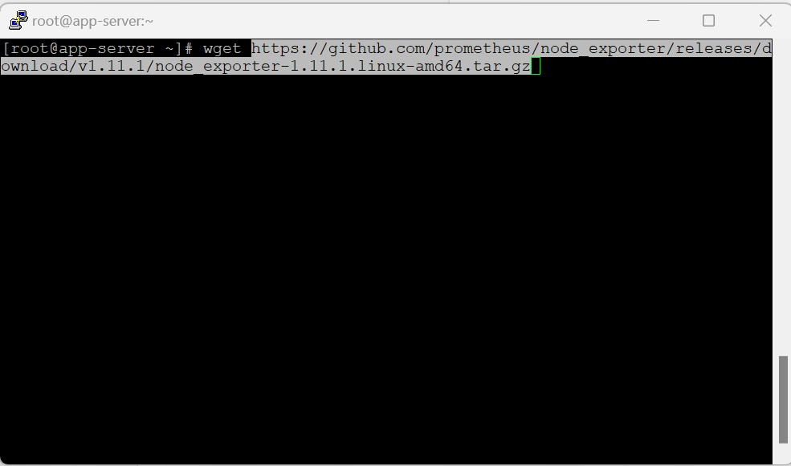
- Check file/folder name (ls)
- And unzip that file (node_exporter-1.11.1.linux-amd64.tar.gz)
- tar –xvzf filename
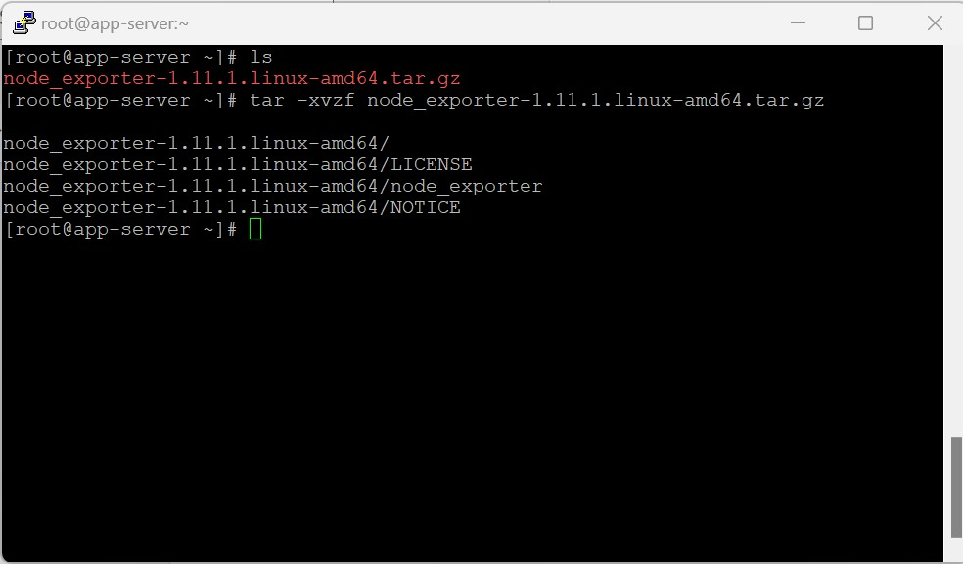

- For moving folder to opt
- mv /root/node_exporter~1.11.1.lunux~amd64 /opt
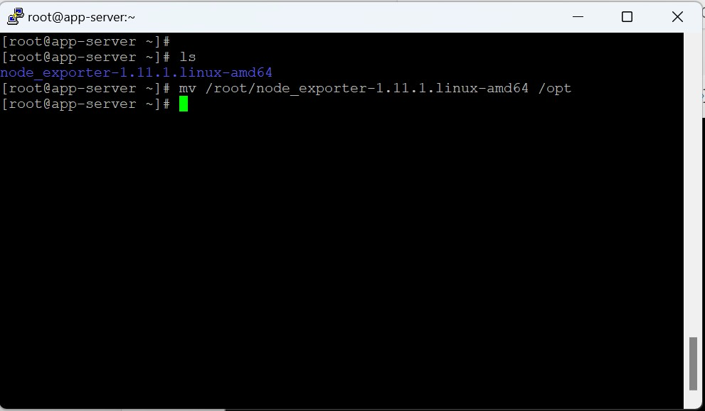

Step5: install Grafana using putty (grafana-server)
- Search download grafana (Standalone Linux Binaries) copy
- Grafana OSS
- wget https://dl.grafana.com/grafana-enterprise/release/12.3.2/grafanaenterprise_12.3.2_21390657659_linux_amd64.tar.gz
- tar -xzvf grafana-enterprise_12.3.2_21390657659_linux_amd64.tar.gz

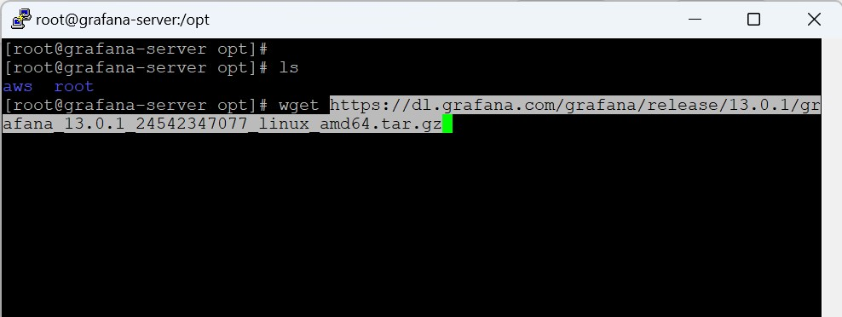

- Check file/folder name (ls)
- And unzip that file (grafana-enterprise_13.0.1_24542347077_linux_amd64.tar.gz) • tar –xvzf filename
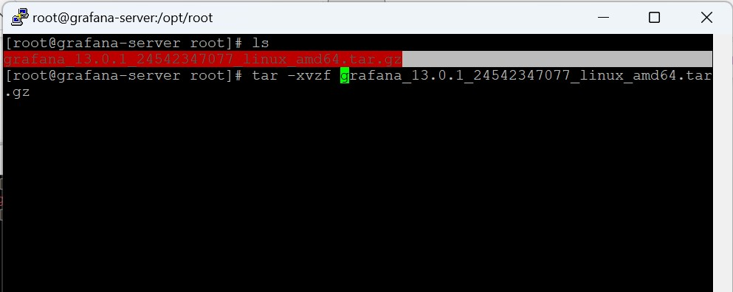 For moving folder to opt
- mv /root/ grafana-13.0.1 /opt
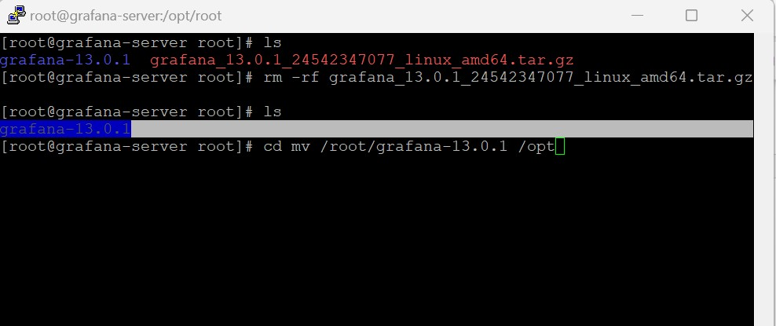

Step6: Open opt folder
- Go to opt folder (cd /opt)
- Go to node exporter folder (cd /node_exporter-1.11.1.linux-amd64)
- Go to node_exporter (. /node_exporter)
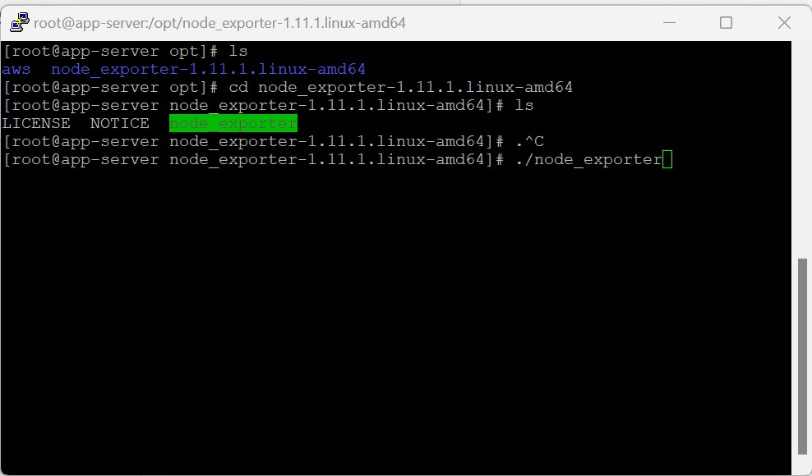

Step7: Open port no on app server port no – 9100
- Prometheus server Port No – 9090
- Grafana server Port No - 3000

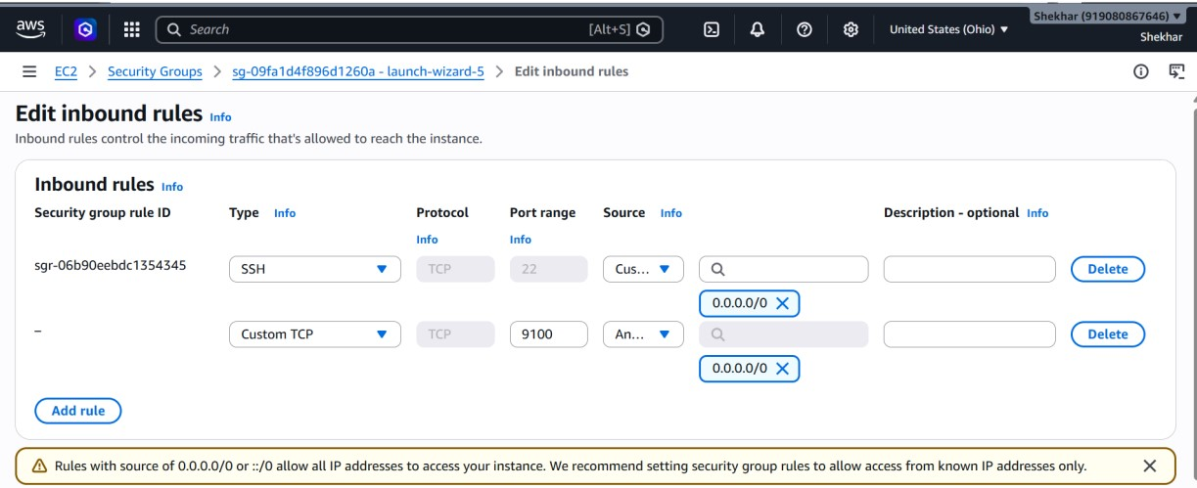

Step8: Open Prometheus yml
- cd /opt
- ls
- cd prometheus-3.11.2.linux-amd64
- Vim prometheus.yml
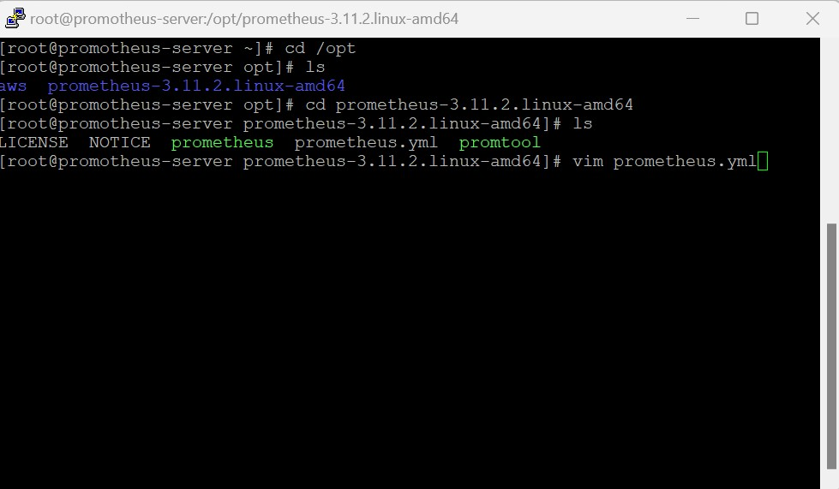

Step9: Open Prometheus yml and provide App-server port no
- static_configs:
- - target: [“localhost:9090”,"private-ip-of-app-server:9100"]
- Save changes (:wq!)
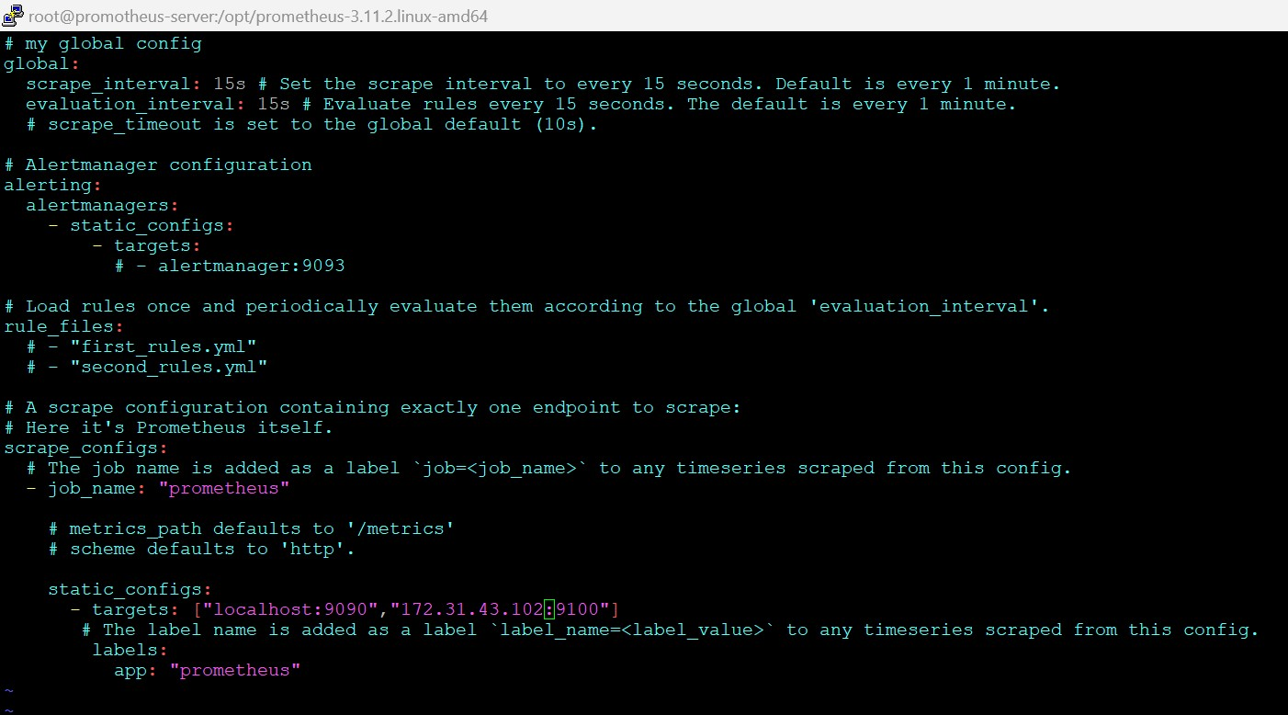

- Run Prometheus (./prometheus)
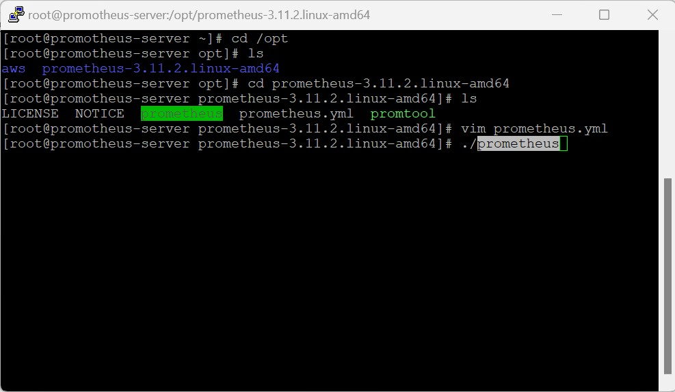

- Copy Prometheus public ip add (instance)
Go to browser and add Prometheus port no (18.117.218.238:9090)
- Its showing Prometheus dashboard

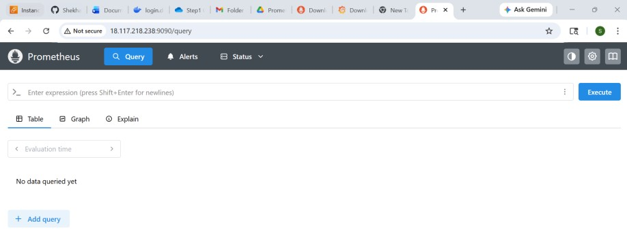
- Goto status dropdown open target health you can monitor your server health
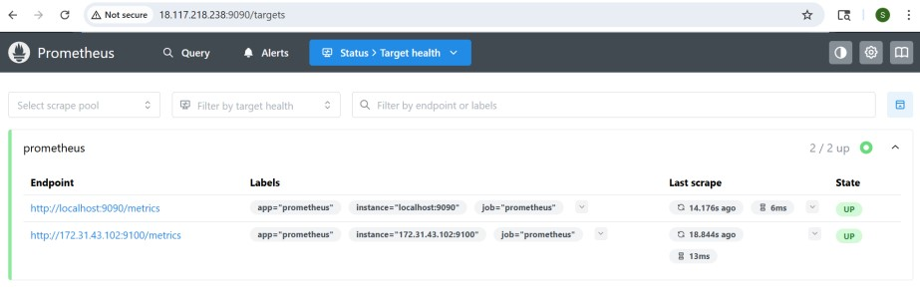

Step10: Open Grafana and provide App-server port no
- cd /opt
- ls
- cd grafana-13.0.1
- bin (folder)
- cd bin
- Run ./grafana-server
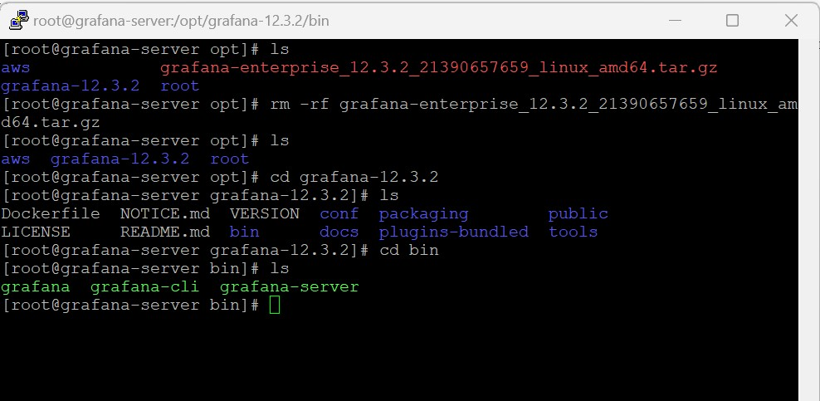
Copy Grafana public ip add (instance)
- Go to browser and add Grafana port no (18.118.29.121:3000)
- Its showing Grafana dashboard
- Username: admin
- Password: admin
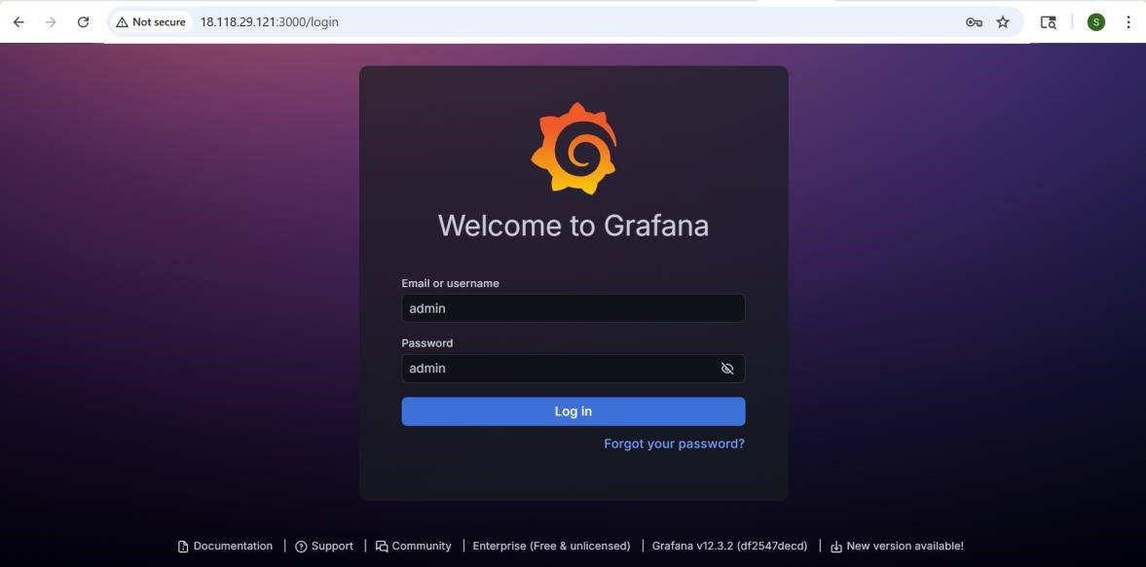

- Change password
- Now you can access Grafna Dashboard
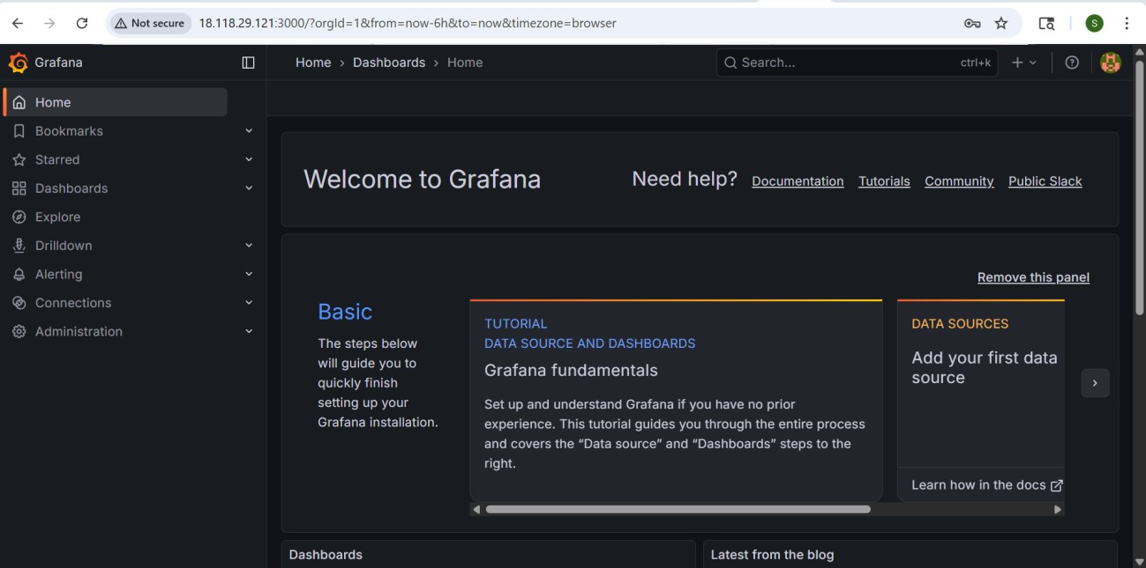
- Go to data home/data sources/prometheus
Connection prometheus server URL (Prometheus ip) with port no
- Start with http:// (http://18.117.218.238:9090)
- Save and test
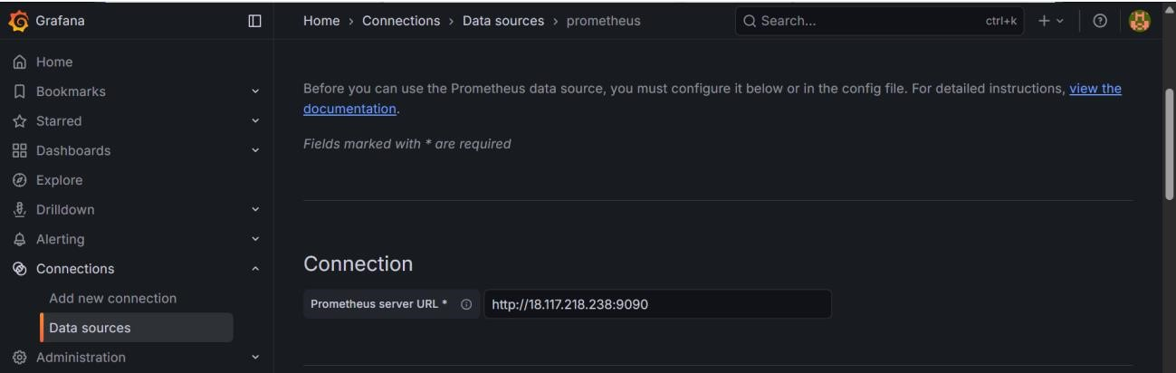
- Go to Dashboard select new/import
- Check Grafana Dashboards
(grafana.com/dashboards)

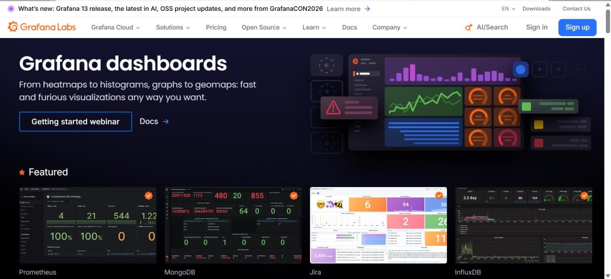Open any dashboard and copy ID
- Add ID and Click on load then import
- Now you can access your Grafana dashboard
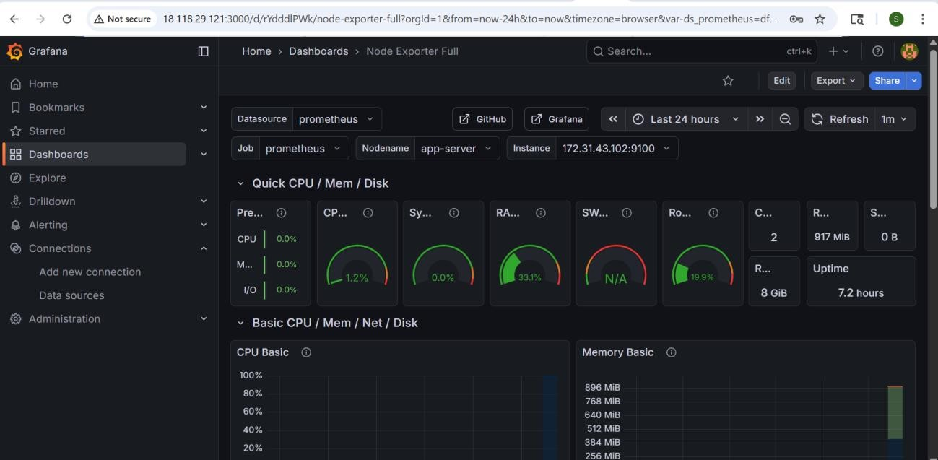

Conclusion
The Prometheus and Grafana monitoring setup on AWS provide an efficient and scalable infrastructure monitoring solution. By integrating Node Exporter with Prometheus and visualizing the collected metrics in Grafana dashboards, the system enables real-time monitoring, performance tracking, and proactive issue detection. This solution improves operational visibility, simplifies troubleshooting, and enhances server reliability in cloud environments.

